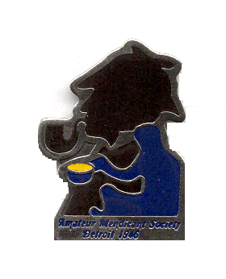Amateur Mendicant Society
Of Detroit, Established 1946

Gasogene: Tide-Waiters:
John Kramb (248) 470-2342 Eddie Stein: (248) 357-3448
Commissionaire: Bev Ellis (734) 416-1388
Chris Music (248) 922-9739 Lascar:
Tantalus: Bobbi Gorevitz
Rob Musial (313) 885-9153

“…I have always had an idea that I would have made a highly efficient criminal.”
-- Sherlock Holmes in “The Adventure of Charles Augustus Milverton”

But there is nothing criminal in this exercise, an evening of dinner, fellowship and the sharing of Sherlockiana with the storied and legendary Amateur Mendicant Society of Detroit.

Saturday, June 1, 2019
6:00 p.m.
The Commonwealth Club
30088 Dequindre, Warren, MI Club phone: (586) 751-9560

Our assigned story and brief discussion is on “The Adventure of Charles Augustus Milverton,” in which Holmes and Watson work to defeat a blackmailer – until fate steps in and plays a hand.

In the evening’s presentation, Scott Monty, a founder of the podcast and website “I Hear of Sherlock Everywhere” will present his investigation into “A Powerful Ring of Blackmailers.” There will also be a dramatic reading of a short Sherlockian play by the AMS Players.

Of course, also included will be the usual toasts, prizes, merriment and more.

Please make checks for $30 payable to: Amateur Mendicant Society of Detroit and mail to the address below. Or to use PayPal, contact amateurmendicantsociety@gmail.com for instructions.

To join us, please mail your check for $30 per person by FRIDAY, MAY 24th to:

AMATEUR MENDICANT SOCIETY OF DETROIT
c/o Bev Ellis
48132 Colony Farm Circle
Plymouth, MI 48170-3305

The dinner includes a tossed salad, chicken Marsala, ginger pork, roasted potatoes, green beans, corn and dessert. As always, there will also be a cash bar.

“Come at once if convenient … if inconvenient, come all the same.”

