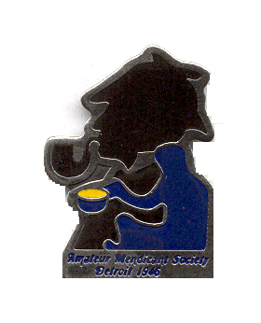Amateur Mendicant Society
Of Detroit, Established 1946

Gasogene: Tide-Waiter:
John Kramb (248) 470-2342 Chris Jeryan (248) 854-2180
Commissionaire:
Chris Music (248) 922-9739 Lascar:
Tantalus: Bobbi Gorevitz
Rob Musial (313) 885-9153

“You do not know Sherlock Holmes yet…perhaps you would not care for him…”
-- Young Stamford to Dr. John Watson in the Criterion Bar

But we know how much you care for Holmes & Watson, so we cordially invite you to join with other Sherlockians as we celebrate the first meeting of these two and the 76th anniversary of the Mendicants.

Saturday, April 23, 2022
6:00 p.m.
The Commonwealth Club
30088 Dequindre, Warren Club phone: (586) 751-9560

Our assigned story is “A Study in Scarlet,” in which Watson and Holmes meet and team up with the Baker Street Irregulars to solve two murders – and the mystery of the Two Pills.

There will be a short discussion of the story by Chris Music and a presentation by playwright and member David MacGregor on “3 ½ Sherlock Holmeses: The Evolution of Popular Culture’s Greatest Hero.”

Also included will be the usual toasts, prizes, merriment and more.

To join us, please make checks for $30 payable to: Amateur Mendicant Society of Detroit and mail to the address below by FRIDAY, APRIL 15th. Or visit PayPal at amateurmendicantsociety@gmail.com for instructions.
AMATEUR MENDICANT SOCIETY OF DETROIT
c/o Chris Jeryan
22129 Metamora Drive
Beverly Hills, MI 48025

Our dinner will include chicken piccata, braised beef, penne pasta with marinara sauce, garlic potatoes, peas with onions, coffee, tea, and soft drinks. As always, there will also be a cash bar.

“Come at once if convenient … if inconvenient, come all the same.”

