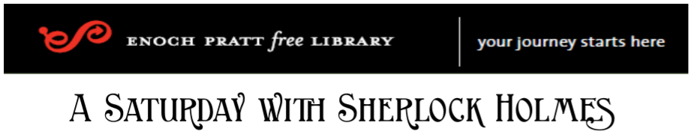
“My Favorite Sherlockian Character”
Saturday, November 14, 2020 – 10 a.m. ONLINE
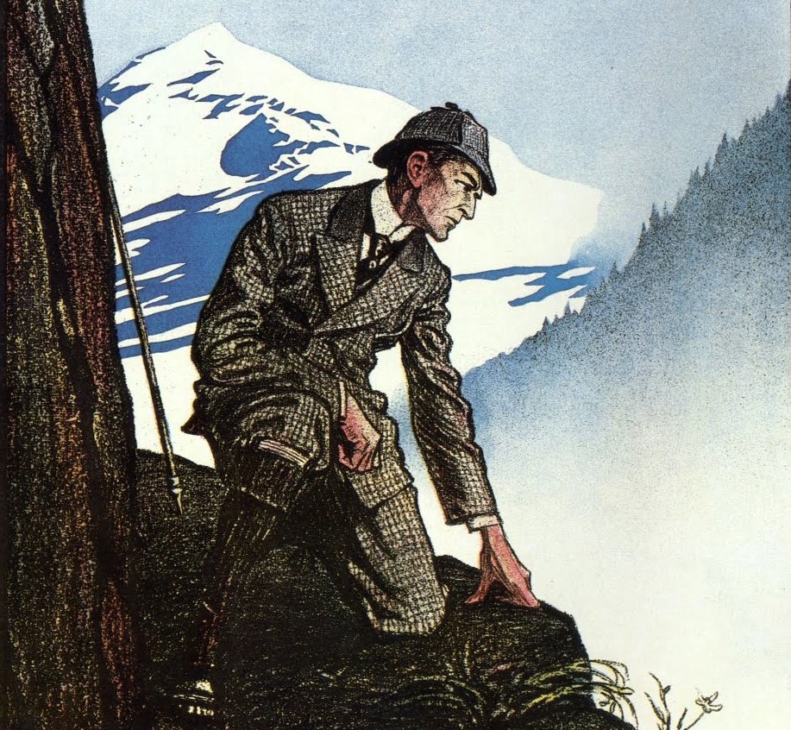

Phil Bergem: Birdy Edwards
Debbie Clark: Kitty Winter
Bob Katz: Sir Leslie Oakshott
Mike McSwiggin: Henry Baker
Brent Morris: Jabez Wilson
Andy Solberg: Professor James Moriarty
Dan Thomas: Inspector G. Lestrade
Karen Wilson: Mary Sutherland
Vincent Wright: John Clay aka Vincent Spaulding

To Register (FREE) & for updates:
https://calendar.prattlibrary.org/event/saturday_with_sherlock_at_the_pratt
