The Hudson Valley Sciontists
will consider
The Adventure of the Six Napoleons

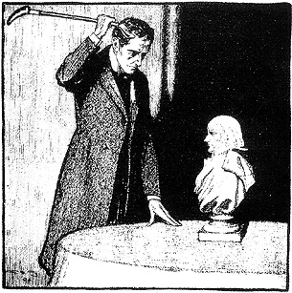

Sunday, May 29, 2022

At Vassar College Alumnae House
Poughkeepsie, New York 12604

6:00 p.m. cocktails (cash bar) 6:30 p.m. dinner
Dinner by Brasserie 292

Your check is your reservation: $60 per person
to Lou or Candace Lewis
2 Loockerman Avenue
Poughkeepsie, NY 12601
clewis1880@aol.com
llewis@lewisgreer.com

JCR/22

