The Hudson Valley Sciontists
will dine and discuss
The Adventure of the Illustrious Client
Friday June 9, 2023
6:00 pm Vassar College Alumnae House

“It can’t hurt now,” said Sherlock Holmes, when after many years, he gave Watson permission to tell the story of the Illustrious client, with its conflict between two women from the opposite extremes of society:

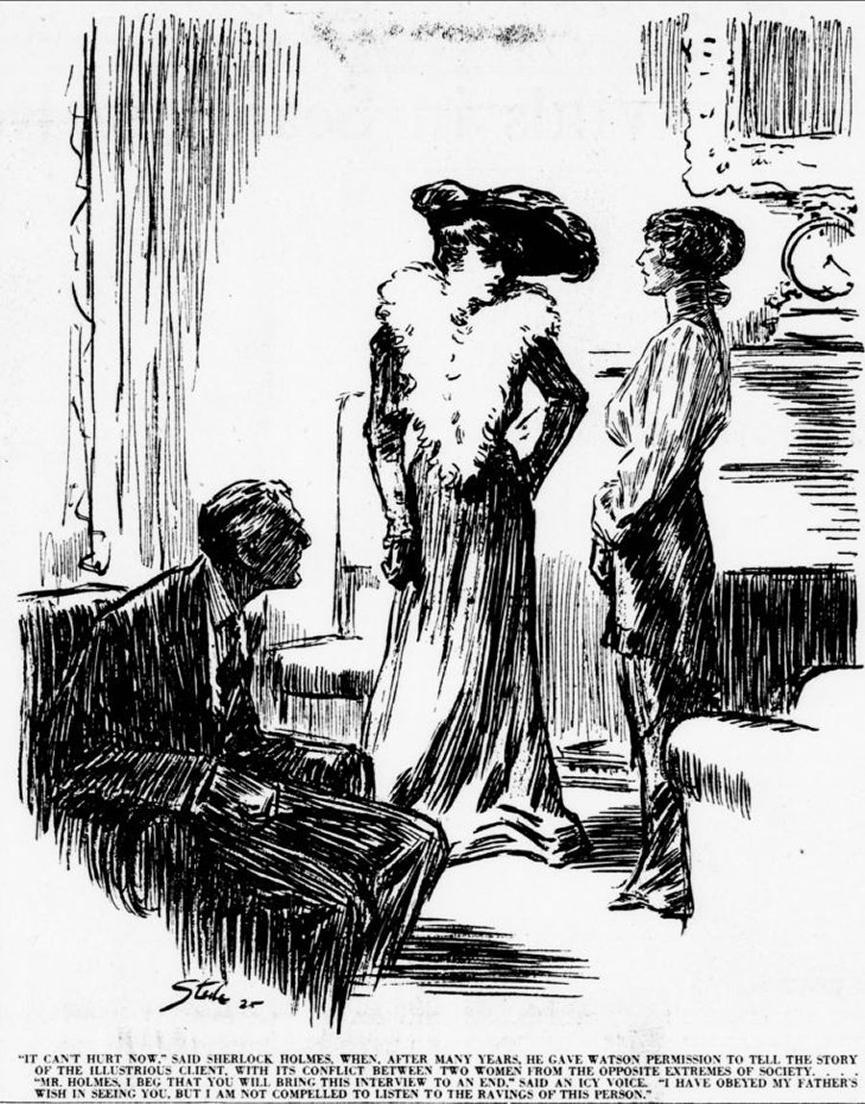

“Mr Holmes, I beg that you bring this interview to an end.” said an icy voice. “I have obeyed my father ‘s wish in seeing you, but I am not compelled to listen to the ravings of this person.”

RSVP with check ($60):
Lou and Candy Lewis, 2 Loockerman Ave, Poughkeepsie, NY 12601. Phone: (845) 471-0296. Email: CLewis1880@aol.com

JCR/2023

