THE SHERLOCK HOLMES CLUB 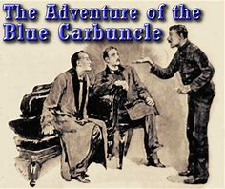 
++++++++++++++++++++++++++++++++++++++++++++++++++++++++++++++++++++++++++++
A neighbor calls upon Holmes and Watson to relate a remarkable tale-his wife has found a precious gem, the recently stolen Blue Carbuncle- in the crop of a Christmas dinner goose! How did the blue diamond find its way from the royal suite of the Hotel Cosmopolitan through the innards of a goose to Holmes’s doorstep? Find out in the exciting Adventure of the Blue Carbuncle
******************************************
The Middlesex Constabulary, the Sherlock Holmes Club of G W, invites you to join us at the Towne Centre on Wednesday, December 27th at 4:30PM
=====================================
Please read the short story prior to the meeting. It is available for free online at www.beaconsociety.com and other sites.
??? Call Paul (609) 642-6314

